INTERNSHIP REPORT

On

HOUSE PRICE PREDICTION SYSTEM

From

ANALYZE INFOTECH

Towards partial fulfillment of the requirements
for the award of degree of

Bachelor of Computer Applications

From

DEPARTMENT OF COMPUTER SCIENCE & ENGINEERING
INTEGRAL UNIVERSITY
LUCKNOW, U.P.

Academic Session 2025-26

INTERNSHIP REPORT

On

HOUSE PRICE PREDICTION SYSTEM

From

ANALYZE INFOTECH

Towards partial fulfillment of the requirements
for the award of degree of

Bachelor of Computer Applications

From

DEPARTMENT OF COMPUTER SCIENCE & ENGINEERING
INTEGRAL UNIVERSITY
LUCKNOW, U.P.

Developed and Submitted by Under Guidance of
< Name of the Student> <Name of the Guide>
< University Roll No> <Designation>

Academic Session 2025-26

School of Computer Applications

Undertaking

This is to certify that Internship Project Report entitled
HOUSE PRICE PREDICTION SYSTEM
being submitted by

<Name of the Student>

Towards the partial fulfillment of the requirements
for the award of the degree of

Bachelor of Computer Applications
to
DEPARTMENT OF COMPUTER SCIENCE & ENGINEERING
INTEGRAL UNIVERSITY
LUCKNOW, U.P.

Academic Year 2025-26

is a record of the student’s own work carried out at

ANALYZE INFOTECH

And to the best of our knowledge the work reported herein does not form a part of any other thesis or work based on which degree or award was conferred on an earlier occasion to this or any other candidate.

Authorized Signatory Students’ Signature
Organization Name Name:
Roll No:

CERTIFICATE

DECLARATION

I, hereby declare that the report entitled “House Price Prediction System” submitted to the School of Computer Applications, Integral University, Kurshi Road, Dashauli, Lucknow, Uttar Pradesh, 226026, is submitted in partial fulfilment of the requirements for the award of the degree of Bachelor of Computer Applications in specialization with Data Science & Artificial Intelligence.
This report is the outcome of my own effort and has been completed under the guidance and supervision of K.K PANDEY SIR. I also declare that the contents of this report have not been submitted, either in full or in part, to any other university or institution for the award of any degree or diploma.

Place: Lucknow
Date:

Signature of the Student
Students’ Name:
University Roll No.:

Acknowledgment

It gives us immense pleasure to express our sincere gratitude to all those who extended their support and guidance throughout the course of this project. The successful completion of this work would not have been possible without the encouragement and assistance of many individuals.
First and foremost, we would like to extend our profound gratitude to Dr. Reena Srivastava, Honourable Dean, School of Computer Applications, Integral University, for her continued support, motivation, and encouragement. Her visionary leadership and guidance have always been a source of inspiration for us. We are also deeply thankful to Dr. Prabhas Chandra Pathak, Head of the Department, School of Computer Applications, for his constant support and valuable insights, which played a vital role in shaping our project and helping us stay focused on our objectives.
We extend our deep appreciation to our project guide, K.K Pandey Sir, for his unwavering support, expert guidance, and timely feedback throughout the duration of the project. His willingness to assist us at every step and address our queries with patience greatly contributed to the successful completion of this work. We would also like to express our gratitude to the Training and Placement Coordinators for their support, cooperation, and guidance during this project.
Last but not the least, we sincerely thank our families and friends for their constant support, understanding, and motivation. Their encouragement has been a strong pillar behind our consistent efforts.

ABSTRACT

The House Price Prediction System is a machine learning-based application developed to estimate the prices of houses by analysing various property-related factors such as location, size, number of rooms, area, amenities, and market trends. The main objective of this system is to provide accurate and reliable house price predictions that help buyers, sellers, real estate agents, and investors make informed decisions.
The system uses historical housing data and predictive algorithms to identify patterns and relationships between property features and their prices. By applying data preprocessing, feature selection, and regression techniques, the model generates estimated property values with improved accuracy. The project also provides a user-friendly interface where users can enter property details and instantly receive predicted prices.
This system reduces the manual effort involved in property valuation and minimizes errors caused by human judgment. It also helps users understand current real estate market trends and supports better financial planning. The House Price Prediction System demonstrates the practical use of data science and machine learning in the real estate industry, making property valuation faster, smarter, and more efficient.

Index
S.No. | Title | Page no.
I | Certificate | IV
II | Declaration | V
III | Acknowledgement | VI
IV | Index | VII-VIII
1 | Introduction | 1
2 | Problem Definition | 2
2.1 | Purpose | 2
2.2 | Scope | 2
3 | Objective | 3
3.1 | Functional requirements | 3
3.2 | Non-Functional requirements | 3-4
4 | Requirement Specifications | 5
4.1 | Hardware requirements | 5
4.2 | Software requirements | 5
5 | Module Description | 6-7
6 | Problem Formulation | 7
7 | Feasibility Study | 8-9
8 | Problem Specifications | 10-15
9 | System Architecture Design | 16-17
10 | System Analysis | 18
11 | E-R Diagram | 19-22
12 | Data Flow Diagram | 23-26
13 | Project Planning & Scheduling | 27-28
14 | Coding | 29-50
15 | Screenshot | 51
16 | Testing | 52-59
17 | Conclusion | 60
18 | Future Scope | 61
19 | Bibliography | 62

INTRODUCTION
The House Price Prediction System is a smart and efficient application designed to predict the prices of residential properties using machine learning techniques. In the modern real estate market, determining the correct price of a house is a challenging task because property values depend on multiple factors such as location, area, number of bedrooms, nearby facilities, market demand, and economic conditions. Traditional methods of property valuation are often time-consuming and may not always provide accurate results.
This project aims to develop an automated system that can estimate house prices based on historical housing data and user-provided property details. The system uses data analysis and machine learning algorithms to study patterns in real estate data and generate reliable price predictions. By using predictive models, the system helps buyers, sellers, investors, and real estate agents make better decisions regarding property transactions.
The House Price Prediction System improves accuracy, reduces manual effort, and provides quick results through a user-friendly interface. It also helps users understand market trends and property values in different locations. This project demonstrates the practical application of artificial intelligence and data science in the real estate sector and contributes to making property valuation more transparent and efficient.
- A House Price Prediction System is a machine learning-based application designed to estimate the price of houses using various features such as location, size, number of rooms, and amenities. It helps buyers, sellers, and real estate agents make informed decisions.
- The system collects historical housing data and analyzes market trends to predict property prices accurately. By using algorithms like Linear Regression, Decision Trees, or Random Forest, the system improves prediction efficiency and reliability.
- This project reduces manual effort and human error in property valuation by automating the price estimation process. It provides quick and data-driven results, which are useful for real estate businesses and customers.
- The House Price Prediction System uses datasets containing factors such as area, number of bedrooms, bathrooms, parking space, and nearby facilities. These factors are processed to generate accurate house price predictions.
- The main objective of this system is to assist users in understanding the estimated market value of properties before buying or selling. It also supports better investment planning and decision-making in the real estate sector.

PROBLEM DEFINITION
In the real estate industry, determining the accurate price of a house is a complex and challenging process. House prices are influenced by many factors such as location, size of the property, number of rooms, infrastructure, market conditions, nearby facilities, and economic trends. Traditional methods of property valuation mainly depend on manual analysis, personal experience, and market assumptions, which may lead to inaccurate pricing and inconsistent results.
Buyers often face difficulties in identifying whether a property is fairly priced, while sellers struggle to decide the correct selling price for their houses. Real estate agents and investors also require reliable price estimation methods to make profitable decisions. Due to the rapid growth of urbanization and fluctuations in the real estate market, manual prediction methods are becoming less efficient and more time-consuming.
The main problem addressed in this project is the lack of an automated and accurate system for predicting house prices based on real estate data. There is a need for a system that can analyze historical housing data, identify patterns, and generate precise price predictions quickly and efficiently.
The House Price Prediction System is developed to solve this problem by using machine learning algorithms and data analysis techniques. The system aims to provide accurate, fast, and data-driven house price predictions, reducing human error and supporting better decision-making in the real estate market.
- Determining the accurate price of a house manually is difficult because property values depend on multiple factors such as location, area, facilities, and market conditions.
- Traditional property valuation methods are time-consuming and may produce inaccurate results due to human assumptions and calculation errors.
- Buyers and sellers often face financial loss because they do not have proper information about the actual market value of properties.
- Analyzing large volumes of housing data manually is inefficient and creates challenges in identifying market trends and pricing patterns.
- The House Price Prediction System solves these issues by using machine learning algorithms to provide fast, accurate, and automated house price predictions.

Purpose:
The main purpose of the House Price Prediction System is to provide an accurate, reliable, and automated solution for predicting house prices based on various property-related factors. The system is designed to help buyers, sellers, real estate agents, and investors make informed decisions regarding property transactions.
The project aims to reduce the difficulties and inaccuracies involved in traditional property valuation methods by using machine learning and data analysis techniques. By analyzing historical housing data and important features such as location, area, number of rooms, and market conditions, the system generates estimated house prices with improved accuracy.
Another purpose of this system is to save time and reduce manual effort in evaluating property values. It also helps users understand real estate market trends and compare different properties effectively. The system provides quick and user-friendly access to price predictions, making the property valuation process more efficient and transparent.
Scope:
The scope of the House Price Prediction System is focused on developing an intelligent and efficient platform that can predict house prices using machine learning algorithms and historical real estate data. The system can be used in the real estate industry to assist buyers, sellers, property dealers, investors, and financial institutions in making accurate property-related decisions.
The project covers the collection, preprocessing, and analysis of housing data based on various factors such as location, area, number of bedrooms, bathrooms, parking facilities, property condition, and nearby amenities. By using these features, the system predicts the estimated price of a house with better accuracy and reduced manual effort.
The system provides a user-friendly interface where users can enter property details and instantly receive price predictions. It can also help users compare property values in different locations and understand current market trends. The project supports faster decision-making and minimizes the chances of incorrect property valuation.
.
OBJECTIVE
The main objective of the House Price Prediction System is to develop an intelligent and automated system that can accurately predict the prices of houses based on different property-related features. The project aims to use machine learning techniques and historical housing data to generate reliable price estimations that help users make better real estate decisions.
The system is designed to analyze important factors such as location, area, number of rooms, facilities, and market trends to determine the estimated value of a property. It helps buyers identify suitable properties within their budget and assists sellers in deciding fair selling prices. The project also supports real estate agents and investors by providing quick and accurate property valuation.
Another objective of the system is to reduce the time, effort, and errors involved in traditional property price estimation methods. The system aims to improve transparency and efficiency in the real estate market by providing data-driven predictions.
The project also focuses on demonstrating the practical application of machine learning and data analysis in solving real-world problems. Additionally, it aims to provide a simple and user-friendly interface that allows users to easily enter property details and obtain instant price predictions.
- To develop a system that can predict house prices accurately using machine learning algorithms and historical housing data.
- To reduce manual effort and human error involved in traditional property price estimation methods.
- To help buyers and sellers make better financial and investment decisions by providing reliable property price predictions.
- To analyze important factors such as location, area, number of rooms, and amenities that influence house prices.
- To provide a fast, efficient, and user-friendly platform for automated house price prediction and real estate analysis.

Functional Requirements:
1. User Input Management
The system should allow users to enter house-related details such as location, area, number of bedrooms, bathrooms, parking facilities, and other property features required for price prediction.
2. Data Collection and Storage
The system should collect and store historical housing data in a database for training and testing the prediction model.
3. Data Preprocessing
The system should clean, organize, and preprocess the dataset by handling missing values, duplicate records, and incorrect data entries.
4. Machine Learning Model Training
The system should train machine learning algorithms using historical real estate data to improve prediction accuracy.
5. House Price Prediction
The system should generate predicted house prices based on the property details provided by the user.
6. Result Display
The system should display the predicted house price clearly and accurately through a user-friendly interface.
7. User Authentication
The system may provide login and registration functionality for administrators or users to securely access the platform.
8. Data Update Facility
The administrator should be able to add, update, or delete housing data and property records from the system.
9. Report Generation
The system should generate reports or summaries related to house price predictions and market analysis.
10. Error Handling
The system should detect invalid inputs and provide appropriate error messages to ensure smooth operation.
11. Search and Comparison
The system should allow users to search and compare different properties based on price and features.
12. System Security
The system should protect user data and maintain secure access to the database and prediction models.
Non-Functional Requirements:
1. Performance
The system should provide fast and accurate house price predictions with minimum response time, even when handling large datasets.
2. Reliability
The system should operate consistently without failures and provide dependable prediction results under normal working conditions.
3. Accuracy
The prediction model should generate highly accurate house price estimations based on historical data and user inputs.
4. Scalability
The system should be capable of handling increasing amounts of housing data, users, and future feature enhancements without affecting performance.
5. Usability
The system should provide a simple, user-friendly, and easy-to-understand interface for all types of users.

6. Security
The system should ensure the protection of user information, housing data, and database records through proper authentication and secure access control.
7. Availability
The system should be available to users whenever required and should minimize downtime during operation.
8. Maintainability
The system should be easy to maintain, update, and improve for future modifications and bug fixes.
9. Compatibility
The application should work properly on different operating systems, browsers, and devices without technical issues.
10. Flexibility
The system should support future integration with advanced technologies, APIs, and additional machine learning models.
11. Data Integrity
The system should ensure that stored data remains accurate, consistent, and free from unauthorized modifications.
12. Backup and Recovery
The system should provide backup and recovery mechanisms to prevent data loss in case of system failure or technical issues.

REQUIREMENTS SEPECIFICATIONS
HARDWARE SPECIFICATION

Component | Minimum Requirement | Recommended Requirement
Processor | Quad-Core (e.g., Intel Xeon / Ryzen) | 8-Core Server Grade CPU (Intel Xeon / AMD EPYC)
RAM | 8 GB | 16–32 GB
Storage |  | 512 GB SSD or NVMe
  256 GB SSD
Network | 10 Mbps or above | 100 Mbps or above

SOFTWARE SPECIFICATION

Software | Description
OS
  Windows 10+, Linux, or macOS
Browser | Google Chrome, Firefox, Safari
Framework | React.js
Libraries
  Axios, React Router, Tailwind CSS, Mongoose, CORS, Multer
API Testing Tool | Postman
  Machine Learning Tools
  Machine Learning Tools

PROBLEM FORMULATION
The House Price Prediction System is formulated to solve the problem of inaccurate and time-consuming property valuation in the real estate sector. House prices are affected by multiple factors such as location, area, number of bedrooms, nearby facilities, market demand, and economic conditions. Due to the involvement of many variables, predicting the correct price of a house manually becomes difficult and unreliable.
The problem can be formulated as a predictive analysis task where historical housing data is used to estimate the selling price of a property. The system takes property features as input variables and predicts the house price as the output variable. The objective is to identify the relationship between property characteristics and market prices using machine learning algorithms.
The formulation of the problem includes collecting real estate datasets, preprocessing the data, selecting relevant features, training prediction models, and evaluating the accuracy of the generated results. The system aims to minimize prediction errors and improve the reliability of price estimation.
Mathematically, the problem can be represented as:
House Price = f (Location, Area, Bedrooms, Bathrooms, Facilities, Market Trends, etc.)
Where:
- Input Variables represent property features.
- Output Variable represents the predicted house price.
- The function f is generated using machine learning algorithms such as Linear Regression, Decision Tree, or Random Forest.
The House Price Prediction System is therefore formulated as a supervised machine learning problem that uses past housing data to predict future property values accurately and efficiently.

FEASIBILITY STUDY
A feasibility study is conducted to determine whether the House Price Prediction System is practical, beneficial, and technically possible to develop. It helps analyze different aspects of the project before implementation. The feasibility study of this project is explained below:
1. Technical Feasibility
The House Price Prediction System is technically feasible because it can be developed using existing technologies such as Python, Machine Learning algorithms, databases, and web development frameworks. Tools like Pandas, NumPy, Scikit-learn, and Flask/Django can be used for data analysis and prediction. The required hardware and software resources are easily available and affordable.
2. Economic Feasibility
The project is economically feasible because the development cost is comparatively low. Most of the technologies and software used in the system are open-source and freely available. The system reduces manual work, saves time, and improves efficiency in property valuation, making it cost-effective for users and organizations.
3. Operational Feasibility
The system is operationally feasible because it is designed with a user-friendly interface that can be easily used by buyers, sellers, and real estate agents. The automated prediction process simplifies property valuation and reduces dependency on manual estimation methods.
4. Legal Feasibility
The project is legally feasible as it does not violate any legal rules or regulations. The system uses publicly available or authorized housing datasets for prediction purposes. Proper security measures can also be implemented to protect user and property data.
5. Schedule Feasibility
The development of the House Price Prediction System can be completed within the planned time period using proper project management and development techniques. The modules such as data collection, preprocessing, model training, testing, and interface development can be implemented step by step within the project schedule.
6. Social Feasibility
The system is socially beneficial because it helps people make better real estate decisions by providing accurate property price estimations. It improves transparency in the housing market and supports informed investment decisions.
Overall, the feasibility study shows that the House Price Prediction System is practical, achievable, and beneficial for real-world real estate applications.

PROBLEM SPECIFICATION
The House Price Prediction System is designed to predict the estimated price of a house based on different property-related factors using machine learning techniques. The system aims to provide accurate and efficient property valuation by analysing historical housing data and user inputs.
Input Specifications
The system accepts various property details as input, including:
- Location of the house
- Area or size of the property
- Number of bedrooms
- Number of bathrooms
- Parking facilities
- Property condition
- Nearby amenities and infrastructure
- Market-related information
These inputs are provided by the user through a user-friendly interface.
Output Specifications
The system generates:
- Predicted house price
- Property value estimation report
- Comparison of property prices (optional)
- Accuracy and analysis results of prediction models
Processing Specifications
The system performs the following operations:
- Data collection from housing datasets.
- Data preprocessing and cleaning.
- Feature selection and analysis.
- Training of machine learning models.
- Prediction of house prices based on user inputs.
- Display of prediction results.
Functional Specifications
- The system should allow users to enter property details.
- The system should process the data accurately.
- The system should predict house prices using trained models.
- The system should display prediction results instantly.
Performance Specifications
- The system should provide fast response time.
- The prediction accuracy should be high.
- The system should handle large amounts of housing data efficiently.
Security Specifications
- User data should remain secure and confidential.
- Only authorized users should access administrative functions.
- The database should be protected from unauthorized access.
The problem specification defines the complete requirements and operational details of the House Price Prediction System for successful development and implementation.
COMPONENT DIAGRAM
The component diagram contains components and dependencies. Components represent the physical packaging of a module of code. The dependencies between the components show how changes made to one component may affect the other components in the system. Dependence in a component diagram is represented by a dashed line between two or more components. Component diagrams can also show the interfaces used by the components to communicate with each other.
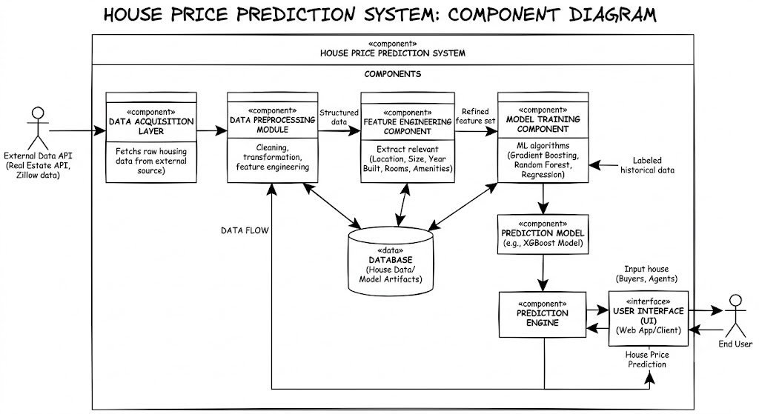
Figure of Component Diagram

DEPLOYMENT DIAGRAM
Deployment and component diagram combine the features of both diagrams into one diagram.
The deployment diagram contains nodes and connections. A node usually represents a piece of hardware in the system. A connection depicts the communication path used by the hardware to communicate and usually indicates a method such as TCP/IP.
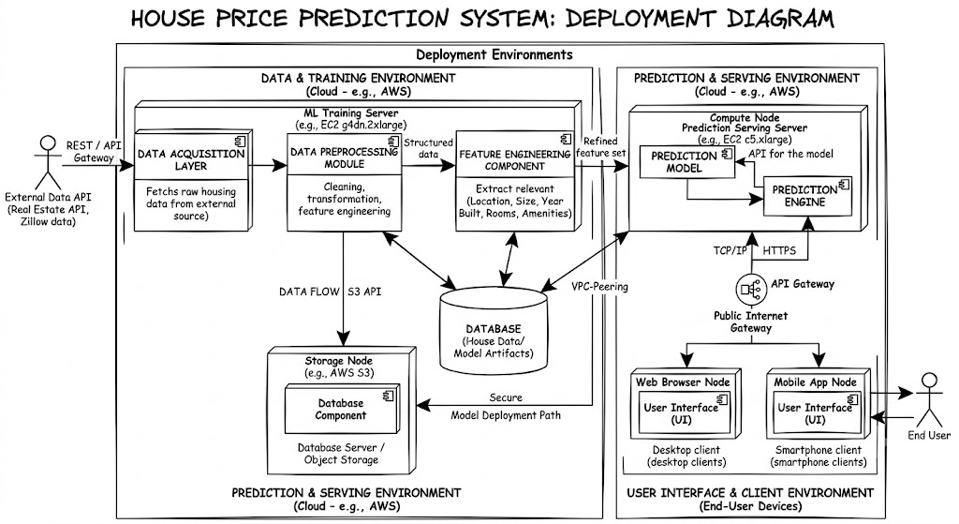

Figure for Deployment Diagram

SYSTEM ARCHETECTURE DESIGN
Defining System:
Collection of components, which are interconnected, and work together to realize some objective, from a system. There are three components in every system, namely input, processing and output

Input Output
Processing

System Development of Life Cycle:
The System development life cycle (SDLC), or Software development process in systems engineering, information systems and software engineering, is a process of creating or altering information systems, and the models and methodologies that people use to develop these systems. In software engineering, the SDLC concept underpins many kinds of software methodologies. Broadly, following are the different activities to be considered while defining the system development life cycle for the said project:
- Problem
- Definition
- System Analysis
- Study of existing system
- Drawback of the existing system
- Proposed system
- System Requirement study
- Data flow analysis
- Feasibility study
- System design
- Input Design (Database & Forms) Updating
- Query /Report
- Design
- Administration
- Testing
- Implementation
- Maintenance
SYSTEM ANALYSIS
System analysis is the process of studying and understanding the requirements, structure, and functionality of the House Price Prediction System. It helps identify the problems in existing property valuation methods and provides suitable solutions using machine learning and data analysis techniques.
The traditional system of house price estimation mainly depends on manual calculations, market assumptions, and personal experience, which often results in inaccurate and inconsistent property valuation. Buyers and sellers face difficulties in determining fair property prices, while real estate agents require reliable tools for faster decision-making. Therefore, there is a need for an automated system that can predict house prices accurately and efficiently.
The House Price Prediction System analyzes historical housing data and various property features such as location, area, number of rooms, facilities, and market conditions. The system processes the collected data using machine learning algorithms to generate accurate price predictions. The analysis phase also focuses on understanding user requirements, system performance, security needs, and prediction accuracy.
Existing System
- Traditional property valuation is done manually.
- Property prices depend on human judgment and market assumptions.
- The process is time-consuming and less accurate.
- There is a higher chance of human error and inconsistent pricing.
Proposed System
- The proposed system uses machine learning algorithms for automated price prediction.
- It analyzes historical housing data to identify price patterns.
- The system provides fast, accurate, and reliable predictions.
- Users can easily enter property details and receive instant results.
Advantages of the Proposed System
- Reduces manual effort and time consumption.
- Improves accuracy in property valuation.
- Helps buyers, sellers, and investors make better decisions.
- Provides a user-friendly and efficient platform.
- Supports real-time and data-driven analysis.

ENTITY RELATION DIAGRAMS
An Entity Relationship Diagram (ERD) is a graphical representation of the database structure used in the Credit Card Fraud Detection System. It shows the entities, attributes, and relationships between different components of the system. The ERD helps in understanding how data is stored, connected, and managed within the application.
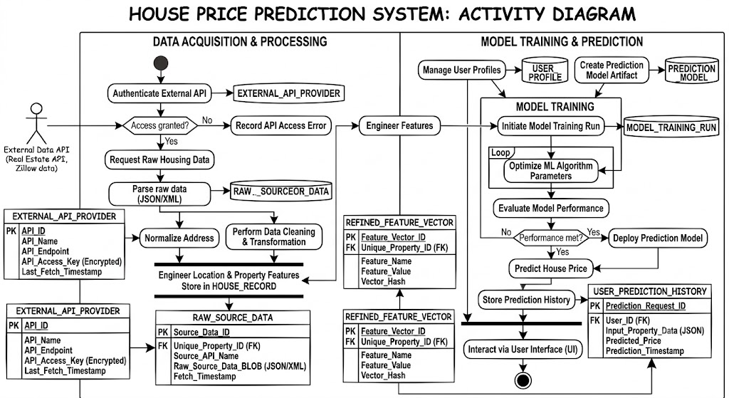
Activity Diagram:

Event Diagram:

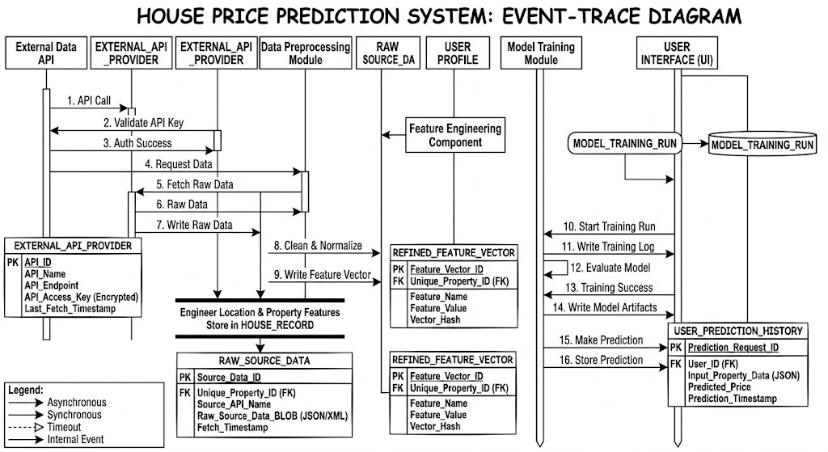
DATA FLOW DIAGRAM
The data flow diagram shows the flow of data within any system. It is an important tool for designing phase of software engineering. Larry Constantine first developed it. It represents graphical view of flow of data. It’s also known as BUBBLE CHART. The purpose of DFD is major transformation that will become in system design symbols used in DFD.
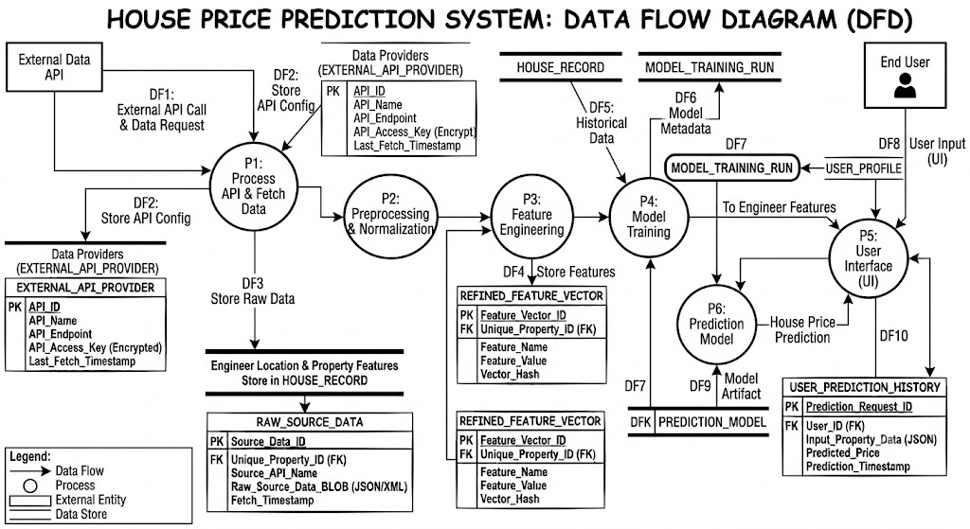
Context Level Data Flow Diagram:
This level shows the overall context of the system and its operating environment and shows the whole system as just one process. Online book store is shown as one process in the context diagram, which is also known as zero level DFD, shown below. The context diagram plays important role in understanding the system and determining the boundaries. The main process can be broken into sub-processes and system can be studied with more detail; this is where 1st level
DFD comes into play.
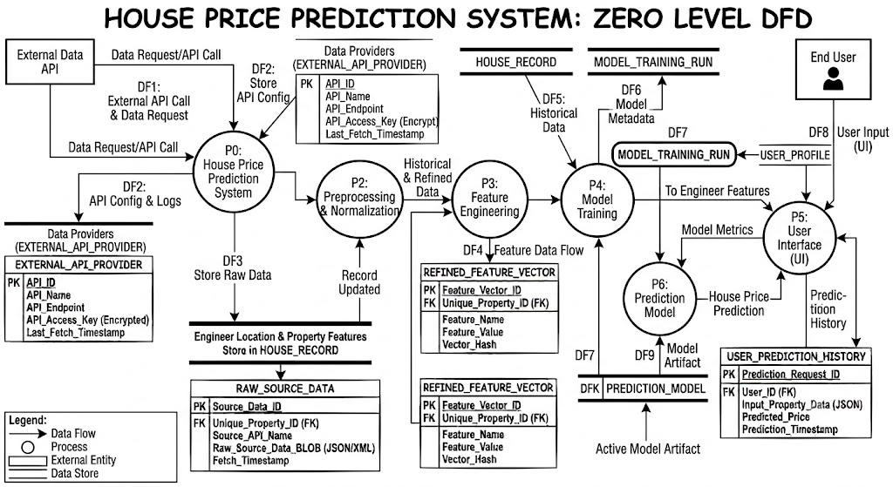

Zero Level Data Flow Diagram
First Level DFD:
This level (level 1) shows all processes at the first level of numbering, data stores, external entities and the data flows between them. The purpose of this level is to show the major high- level processes of the system and their interrelation. A process model will have one, and only one, level 1 diagram. A level 1 diagram must be balanced with its parent context level diagram, i.e. there must be the same external entities and the same data flows, these can be broken down to more detail in level 1.
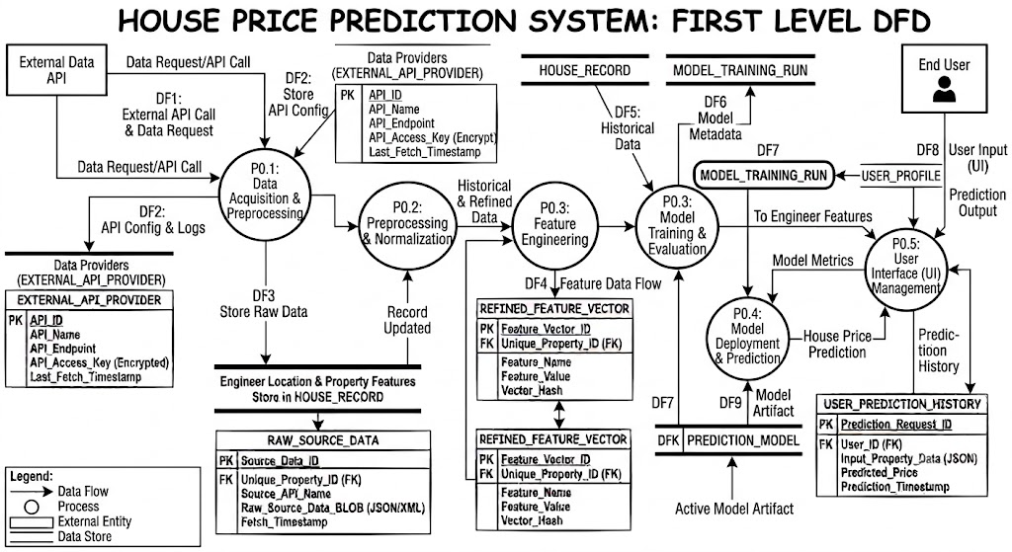
First Level Data Flow Diagram

Class Diagram

PROJECT PLANNING & SCHEDULING

Pert Chart:
A project plan needs to be created to ensure the timely completion of the project. As part of project analysis, we break the project down to a number of stages and use a Gantt chart and PERT chart to describe specific tasks and status.
ID | Task Name | Duration | Start | Finish
1 | Project Initiation | 03 days | Tue  18/04/2026 | Fri  21/04/2026
2 | Draft Project Plan | 02 days | Sat  22/04/2026 | Mon  24/04/2026
3 | Analysis Phase | 09 days | Wed  26/04/2026 | Fri  07/05/2026
4 | Plan User Interviews | 02 days | Sat  08/05/2026 | Mon  10/05/2026
5 | Schedule users Interviews | 04 days | Tue  11/05/2026 | Sat  15/05/2026
6 | Conducting users Interviews | 03 days | Mon  17/05/2026 | Thu  20/05/2026
7 | System Design | 10 days | Fri  21/05/2026 | Mon  31/05/2026
8 | Modules Design | 09 days | Tue  01/06/2026 | Thu  10/06/2026
9 | Data Structure Design | 03 days | Fri  11/06/2026 | Mon  14/06/2026
10 | User Interface Design | 02 days | Tue  15/06/2026 | Thu  17/06/2026
11 | Coding Phase | 07 days | Fri  18/06/2026 | Fri  25/06/2026
12 | Testing Phase | 05 days | Fri  25/06/2026 | Wed  30/06/2026
13 | Integration Testing | 03 days | Wed  30/06/2026 | Fri  02/07/2026
14 | System Level Testing | 03 days | Fri  02/07/2026 | Mon  05/07/2026
15 | Implementation | 02 days | Tue  06/07/2026 | Wed  07/07/2026
16 | Post-Implementation Review | 04 days | Thu  08/07/2026 | Mon  12/07/2026

CODING OF PROJECT

App.jsx

Dashboard.jsx

Backend/index.js

🔐Signup
🔓 Login

❤️ Save Card Info

DATABASE TABLES

User

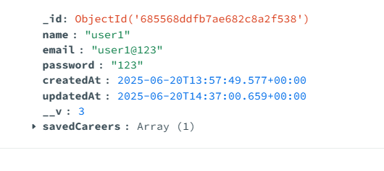

Assesment

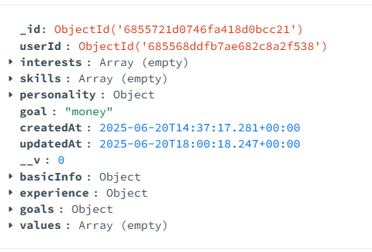

PROJECT SCREENSHOT
Home Page

About

Analysis

History

Prediction

Profile

TESTING
- Testing Plan
- Testing Strategy
- Testing Methods
- Test cases and results
Testing:
Generally, it has been specified thought for testing that: “Testing is the critical element of any software quality assurance and represents the ultimate review of specification, design and code generation.” Software testing has a dual function; it is used to establish the presence of defects in program and it is used to help judge whether the program is usable in practice. Thus software testing is used for validation and verification, which ensure that software conforms to its specification and meets the need of the software customer.
Testability
Software Testability is simply how easily a computer program can be tasted. The check list that follows provides a set of characteristics that lead to testable software.
- Operability
- Observables
- Controllability
- Decomposability
- Simplicity
- Stability
- Understandability
The following are the attributes of the Good Test:-
- A good test has a high probability of finding an error.
- A good test is not redundant.
- A good test should be “Best of Breed”.
- A good test would be neither too simple nor too complex.
Interdependency: Interdependencies of each compartmentalized activity were then found out. Some tasks must occur in sequence while there are many tasks which can occur in parallel.
Software Inspection: Analyze and check system representations such as the requirements document, design, diagrams and the program source code. They may be applied at all stages of process.

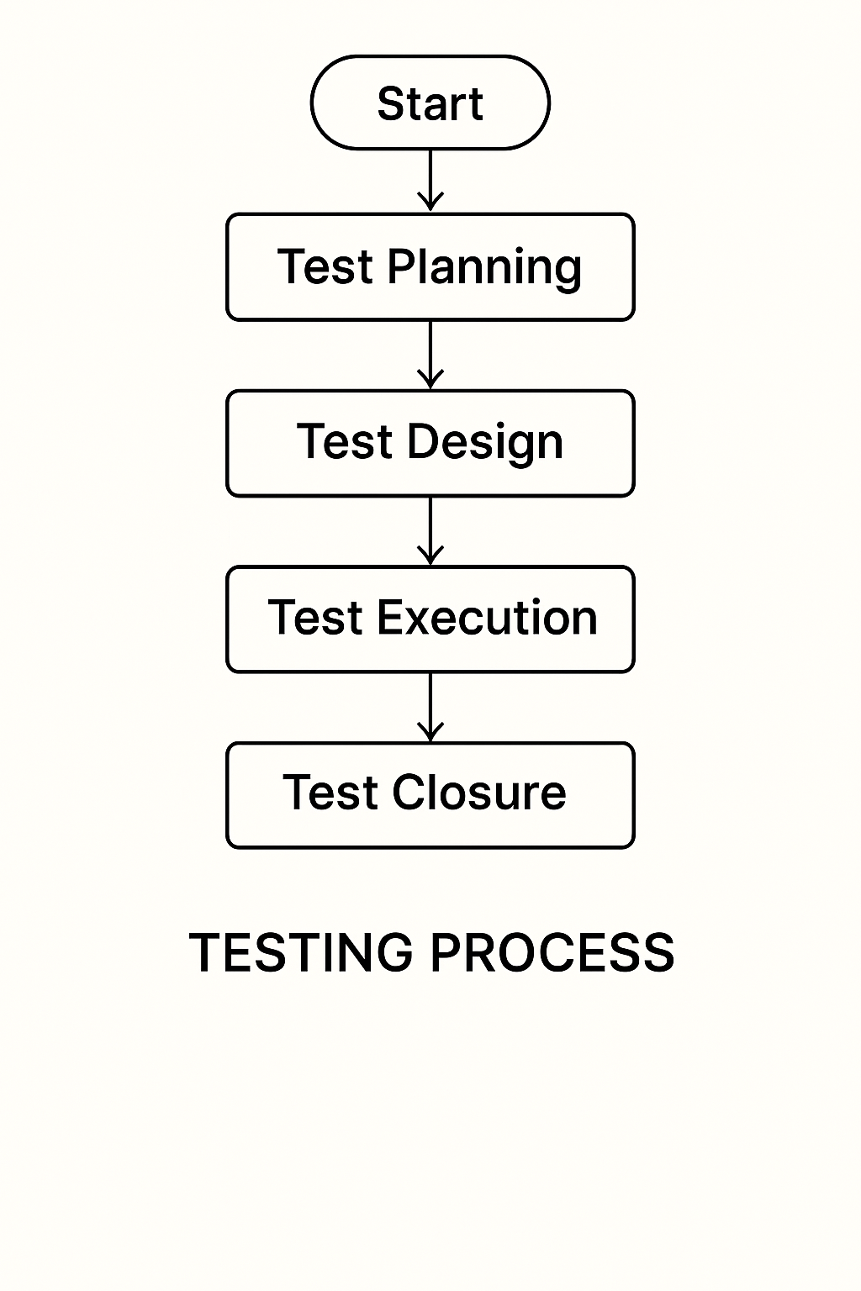

Figure for Testing Process

Test Plan:
The Testing Process: Developer tests the software process activity such as design, implementation and the requirement engineering. Because, design errors are very costly to repair when the system has been started to operate. Therefore, it is quite obvious to repair them at early stage of the system. So, analysis is the most important process of any project.
Requirements Tractability: As most interested portion is whether the system is meeting its requirements or not, for that testing should be planned so that all requirements are individually tested. Developer checked the output of certain combinations of input, which gives desirable results, or not. Strictly stick to our requirements specifications, give you the path to get desirable results from the system.
Tested Items
Our tested items are like:
- Data fetching from the database
- Data insertion, updating and deleting in the database
- Form access to login
Testing Schedule:
Developer has tested each procedure back to back so that errors and omissions can be found as earliest as possible. Once the system has been developed by fully developer tested it on other machines, which differs in configuration.
Testing Methods:
Software testing involves executing an implementation of the software which tests data and examining the outputs of the software and its operational behavior to check that it is performing as required.
Statistical Testing:
Statistical testing is used to test the program’s performance and reliability and to check how it works under operational conditions. Tests are designed to reflect the actual user inputs and their frequency. The stages involved in the static analysis for this system are follows:
Control Flow Analysis:
- Unreachable code
- Unconditional branches into loops
Data Use analysis:
- Variable used before initialization
- Variables declared but never used
- Variables assigned twice but never used between assignments
- Possible array bound violations
- Declared variables
Interface Analysis:
- Parameter type mismatches
- Parameter number mismatches
- Non-usage of the results of function
- Uncalled functions and procedures
Storage Management Faults:
- Data not stored in proper tables
- Data cannot be fetched from proper table
Defect Testing:
Defect testing is intended to find inconsistencies between a program and its specifications. These inconsistencies are usually due to the program faults or defects.
Loop Testing:
The Tester has tested some conditions in a code of application. So, they test the looping in source code of application for finding miss route or any error or wrong direction of flow in code.
Black-Box Testing:
In black box testing or functional testing, the developer is concerned about the output of the module and software, i.e. whether the software gives proper output as per the requirements or not. In another words, this testing aims to test a program behavior against specification without making any reference to the internal structure of the program or the algorithms used.
This can be done in the following way:
- Input Interface
- Processing
- Output Interface.
Whitebox Testing:
It is also called ‘GLASS BOX’ or ‘STRUCTURAL’ testing. Tester has access to system design.
- Simple Loops
- Nested Loops
- Concatenated Loops
- Unstructured Loops
- Continuous Loops
Advantages of White box testing:
- As the knowledge of internal coding structure is prerequisite, it becomes very easy to find out which type of input / data can help in testing the application effectively.
- The other advantage of white box testing is that it helps with optimizing the code.
- It helps in removing the extra lines of code, which can bring in hidden defects.
Structure Testing:
Developer has done his path testing to exercise every independent execution path through a component or program. If every independent path is executed, then all statements in the components must have been executed at least once. The structure of our program is also checked.
Integration Testing:
After our individual modules the Developer tested out Developer go to the integrated to create a complete system. This integration process involves building the system for problems that arise from component interactions. Developer has applied a top-down strategy to validate high-level components of a system before design and implementations have been completed.
Performance Testing:
Performance testing is designed to test the runtime performance of the system within the context of the system. These tests Developer performed as module level as developer as system level. Individual modules developers tested for required performance.
Condition Testing:
Condition testing is a test case design method that exercises the logical conditions contained in a program module. If the condition is incorrect, then as least one part of the condition is incorrect. It may include:
- Boolean variable error
- String index out of Bound error
- Null pointer Assignment
- Input Output Connection Exceptions
- Arithmetic expression error
- Parsing (conversion) errors
- Image unloaded errors
Interface Testing:
Interface testing is an integral part of integration testing. Therefore, the developer checked for the following.
- Interface misuse
- Interface misunderstanding
Developer examined the code to be tested and explicitly list each call to an external component. In the system, standards tests for various modules have been performed, which are follows.
Object Testing:
Object testing is to test objects as individual components, which are often larger than single function. Here the following activities have taken place.
- Testing the individual operations associated with object.
- Testing individual object classes.
- Testing cluster of objects.
- Testing object-oriented systems.
Now we will discuss how testing and debugging is done of this application. Our application can be divided into parts like:
- To make queries to database and retrieve information from it.
- Reduce some memory requirements for the database.
- Maintain database so that unauthorized access can not affect.
Limitations
- It can run only on windows servers. It is not compatible with LINUX servers.
- It is not cent percent safe from professional hackers.
- Only registered user can buy and sell their items using this website.
CONCLUSION
The House Price Prediction System is an effective and intelligent solution for predicting property prices using machine learning techniques and historical housing data. The system helps buyers, sellers, real estate agents, and investors make informed decisions by providing accurate and reliable house price estimations.
The project successfully reduces the limitations of traditional property valuation methods, which are often time-consuming and dependent on manual analysis. By analyzing important factors such as location, area, number of rooms, facilities, and market trends, the system generates quick and data-driven predictions with improved accuracy.
The House Price Prediction System also demonstrates the practical application of artificial intelligence, data science, and predictive analytics in the real estate industry. The system improves efficiency, minimizes human error, and provides a user-friendly platform for property valuation.
Overall, the project proves that machine learning can play an important role in solving real-world problems related to real estate price estimation. With future enhancements and advanced technologies, the system can become more accurate, scalable, and beneficial for modern property management and investment decisions.

- The House Price Prediction System provides accurate and reliable estimation of property prices using machine learning techniques.
- The system reduces manual effort and human errors involved in traditional house valuation methods.
- It helps buyers, sellers, and real estate agents make better financial and investment decisions.
- The project saves time by automatically analysing housing data and predicting prices efficiently.
- Overall, the system offers a smart, user-friendly, and data-driven solution for real estate price prediction.

FUTURE SCOPE OF THE PROJECT
The House Price Prediction System has significant future scope in the real estate industry due to the growing demand for accurate and intelligent property valuation systems. The project can be further improved and expanded by integrating advanced technologies and additional features to increase prediction accuracy and user experience.
In the future, the system can be enhanced by using advanced machine learning and deep learning algorithms for more precise price prediction. Real-time market data and online property listings can also be integrated to provide updated and dynamic house price estimations. The system may include Geographic Information System (GIS) and map-based analysis to evaluate the impact of location and nearby facilities on property prices.
The project can also be developed as a mobile application to provide easy access for users on smartphones and tablets. Cloud-based storage and processing can be implemented to improve scalability, security, and performance. Additional features such as property recommendations, investment analysis, market trend forecasting, and chatbot support can make the system more intelligent and user-friendly.
Furthermore, the system can be expanded to predict prices for commercial properties, rental houses, and land valuation. Integration with banking and loan systems can also help financial institutions evaluate property values for loan approval and risk analysis.
Overall, the future scope of the House Price Prediction System is very broad, and with continuous technological advancements, it can become a highly efficient and smart solution for the real estate sector.

BIBLIOGRAPHY
Reference Books:
• Introduction to Machine Learning with Python: A Guide for Data Scientists- By Andreas C. Müller & Sarah Guido, Machine Learning- The Complete Reference- with Python Data Science Stack (Wes McKinney, Jake VanderPlas, and Aurelien Geron).
• Hands-On Machine Learning with Scikit-Learn, Keras, and TensorFlow: Concepts, Tools, and Techniques to Build Intelligent Systems- By Aurélien Géron, The Complete Reference- Data Science and Predictive Analytics (Max Kuhn, Kjell Johnson, and Ian H. Witten).
Reference websites:
• www.github.com/scikit-learn
• www.kaggle.com
• www.towardsdatascience.com

